MACHINE PROBLEM 5 (PYTHON)

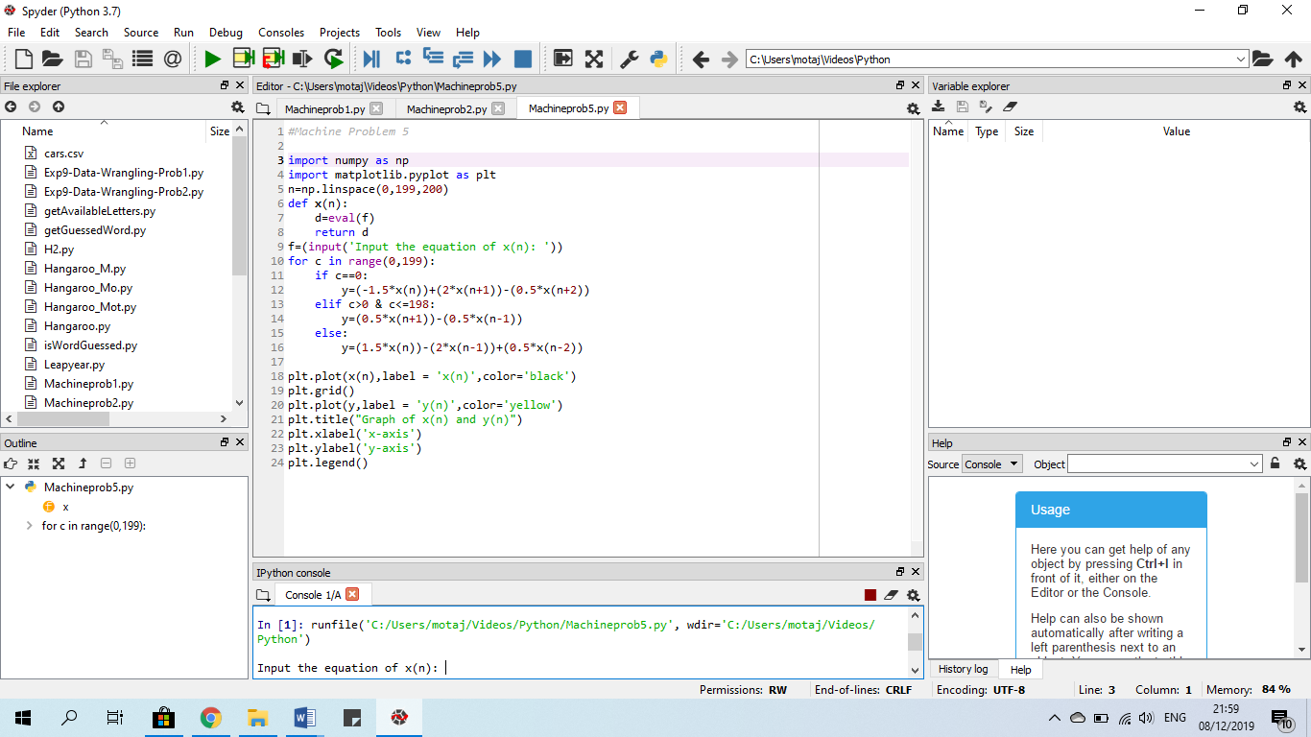

PROOF OF TESTING

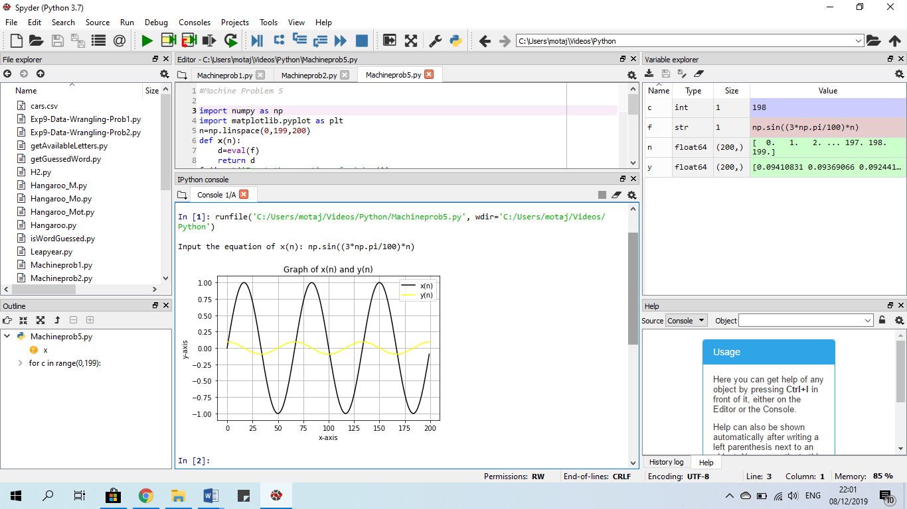

GRAPH

